|  |
| --- |
|  |



|  |  |
| --- | --- |
|  | How to Sell Digital Products on eBay.com |

No part of this book can be transmitted or reproduced in any form including print, electronic, photocopying, scanning, mechanical or recording without prior written permission from the author.

All information, ideas and guidelines presented here are for educational purposes only. This book cannot be used to replace information provided with the device. All readers are encouraged to seek professional advice when needed.

While the author has taken utmost efforts to ensure the accuracy of the written content, all readers are advised to follow information mentioned herein at their own risk. The author cannot be held responsible for any personal or commercial damage caused by misinterpretation of information or improper use of the information.

**Table of Contents**

Contents

Introduction 3

Changes to the eBay Stores as of 1 May 2013 4

Casual eBay Sellers 4

Opening an eBay Store 5

Benefits of running an eBay Store 8

How do you open an eBay Store? 11

How to place an ad on eBay 12

Best times to list eBay items for sale 17

How long should you list your products for sale 17

How should you sell your eBooks for on eBay 17

How much does “print on demand” companies charge 18

Your eBay Digital Product Ad disclaimers 18

Negative Feedback 19

Sales Funnels for eBay sales 19

Conclusion 20

# Introduction

In 2008 eBay changed their policy on digital product sales stating that they no longer permitted digital products being sold on eBay unless it was physically sent in the mail on a CD.

Many people believe this was a bad decision made by eBay because of the growing popularity of eBooks in the marketplace, however, eBay have maintained the ban on digital downloads to this day.

eBay also changed their fee structure (again!!) and these new changes effective 1 May 2013 are set out in detail in this eBook.

Selling your digital products on eBay physically in the mail is not the worst case scenario, and some eBay eBook resellers have claimed to sell many eBooks over the years despite the CD postage requirement.

Most eBay resellers don’t actually burn a CD every time the make a sale, instead they contract out to a CD fulfilment company to “fulfil on demand” their eBay sales as the orders are placed by customers. This way the resellers keep their costs low and because fulfilment companies are very fast, and usually quite cheap, they still provide a quick low cost service to customers providing your source someone local to fulfil your orders.

Many people publish an eBook with every intention of it being sold everywhere, including on eBay for a few dollars. This is because they are selling their eBooks to market their business and/or services and the cheap eBook sale is simply to capture a potential customer’s attention. This is known as a “sales funnel”.

There are hundreds of eBooks available to buy on eBay every day, and often the sellers will sell a huge collection of eBooks in one sale for a few dollars. These books are MRR (Master Resell Rights) eBooks and they are the typical mass produced eBook content that is very common in internet marketing.

The attraction of selling your eBooks on eBay is to market your business and/or services to a whole new audience. On the other hand, you may just want to sell MRR eBooks on eBay as a reseller, and you just want to profit from selling the eBooks themselves.

Whether you are selling a few of your own eBooks on eBay, or a high volume of sales on eBay as a reseller, your advertising strategy on eBay will be different.

In this eBook we:

* Discuss the new changes to the eBay stores
* Show you how to place an ad on eBay
* Recommend places to acquire more eBook digital products to sell on your eBay store
* Show you an eBook “digital product sales funnel” for those wishing to sell their eBooks on eBay

# Changes to the eBay Stores as of 1 May 2013

As of 1 May 2013 you can either sell your products as an individual (which allows up to 40 free listings per month) and you only pay a percentage of the sale price “if” it sells; alternatively you may want to sell a lot of digital products and open an eBay store.

## Casual eBay Sellers

If you don’t intend to sell more than 100 digital products a month, you should seriously consider joining eBay as a casual user, and not opening an eBay store. You can always change from a casual user to an eBay store, and vice-versa, later on, there is no penalty to do so.

There are various fees involved with selling on eBay casually, they include:

* Insertion fees (for over 40 listings a month)
* Featured listing upgrade fees (optional)
* Final value sale price fees (9.9%)
* Paypal fees (if relevant) usually under 5%

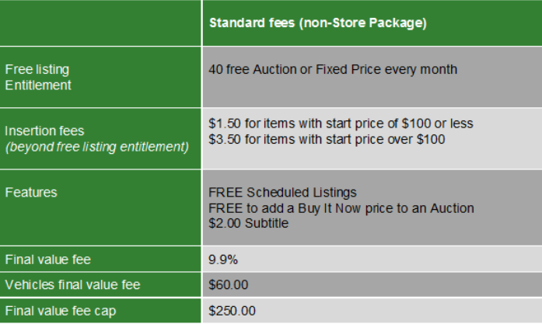

*Above: Casual eBay seller fees as at 1 May 2013*

## Opening an eBay Store

You have to pay a monthly fee to open an eBay store, the monthly subscription prices are as follows:

1. Basic Store $19.95 per month
2. Featured Store Package $49.95 per month
3. Anchor Store $499.95 per month

There are also other fees involved for eBay store owners. They are:

* Listing fees (after “free” listings are made per month)
* Auction “start” fees (from $1.50 to $3.50 for auctions and 20-50c for the cheaper stores)
* Final value fees (6-8%)
* Featured listing upgrade fees (optional)
* Paypal fees (if relevant) usually under 5%

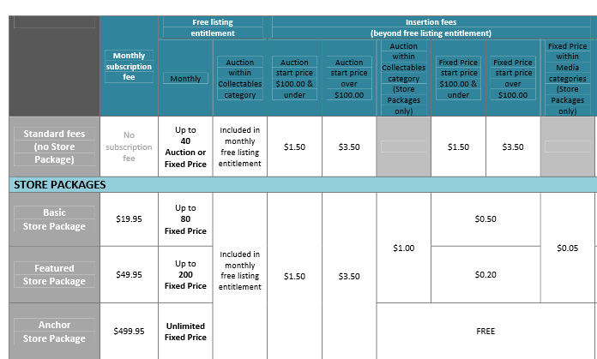

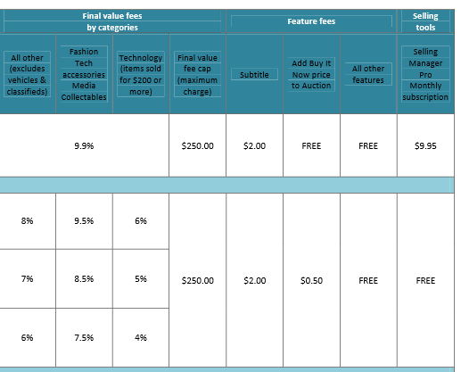

*Above: The two above charts are the chart below (in full)*

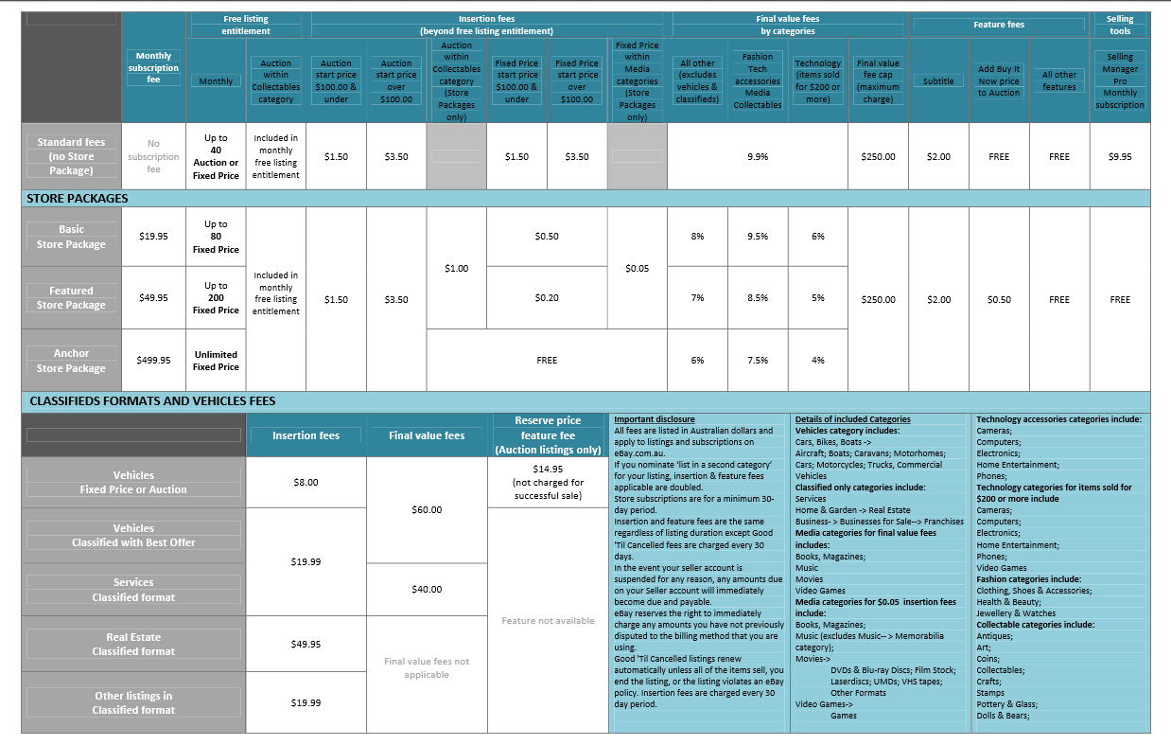

*Above: The latest PDF by eBay on their eBay Store pricing*

*structure as at 1 May 2013.* [*Click Here to Download.*](http://sellercentre.ebay.com.au/sites/default/files/Selling%20fees%20table%20-%20May13.pdf)

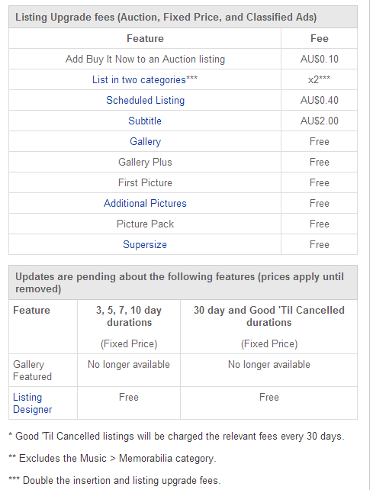

*Above: Extra costs incurred for “upgrades” to the standard ad*

eBay state on their media release that the reason for including higher fees for auctions (for eBay Stores) is to deter eBay store owners having auctions because eBay believe shoppers prefer BIN (buy it now) prices, not auctions from eBay stores. Therefore, eBay have included financial benefits to eBay Store owners to use BIN listings rather than auctions.

# Benefits of running an eBay Store

When we “search” how many “books on disc” listings are current today, it shows 3,681. That’s a lot of books. This indicates that eBooks sell well on eBay despite them being sent by CD. I’m sure there are some people out there that would rather their eBook on a CD rather than having to download it.



The benefits of an eBay store include a homepage to yourself (although it doesn’t allow for much customisation) but it is a place for your customers to go and learn more about your business and the categories in your store. There is also an “About Me” page where you can add pictures or anything that personalises you as more than just a business out to make a profit. It also encourages people to leave positive feedback about your business if they feel they know you personally.

Below are a few successful eBook resellers on eBay at the moment, notice their special awards, feedback percentages are very high, and it also shows the number of eBooks they actually listing right now.



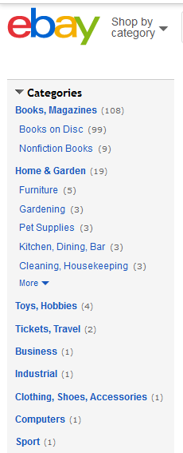 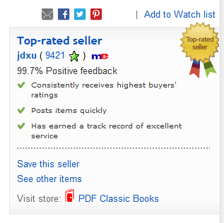

Notice above, the reseller has over 100 eBooks curently for sale, and he has a high positive feedback rating of over 9,000, with 99.7% postive feedback.

Also notice the “Store” is named “PDF Classic Books”. See the line above it which says “See Other Items”, everyone has this option, and if you choose not to open a store at first, then this “See Other Items” selection shows the buyer all your items just like a store would anyway, and buyers use this tool a lot.

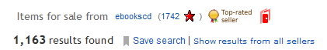

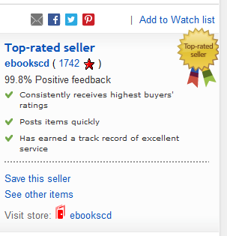 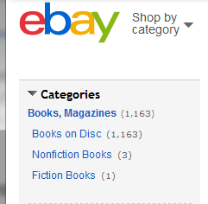

“ebookscd” (above) is also a good seller with a high rating and good feedback level, notice he has over 1,000 eBooks on sale right now. Notice he only sells eBooks, nothing else.

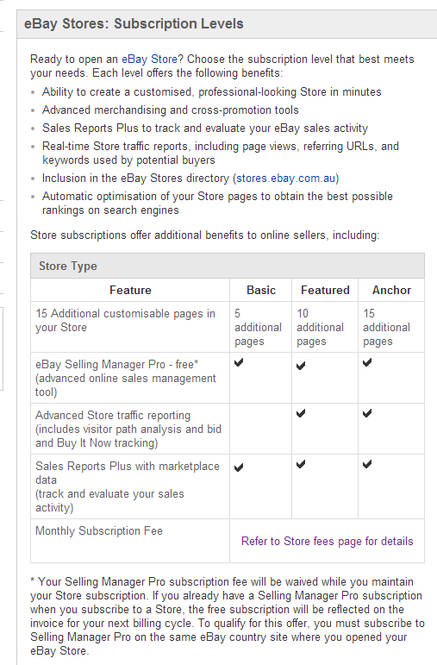

*Above: Setting out the benefits of the*

*different subscription levels of the “eBay stores”*

The main feature of opening your own eBay store is that you can have “categories” and its great accounts management abilities.

One huge advantage over other online stores like Amazon is that you actually DO receive the email address of the customer (unlike Amazon who tell you nothing about your customers because they fulfil the digital orders).

eBay will also help you along the way, once you have proven yourself as a good reliable seller (via your feedback) with selling tools like a “Top Rated Seller” badge (if you meet the requirement to qualify for it) and often favours your search results over other customers. Shoppers always like to deal with companies who have “proven” themselves too, so it helps get sales in more ways than one.

When you think about it, most online “eCommerce” stores sell their accounts for at least $20 per month for you to use their software to sell your items, so with eBay, you are paying the same if you go with the cheapest store option ($19.95 per month) but its unlimited products and they drive all the traffic to buy your product.

In fact, its not uncommon for eCommerce stores to sell on their own website and eBay, utilising eBay to drive traffic where their own website fails them due to poor SEO. eBay are aware that eBay sellers do this, and are very strict that you don’t direct the customer “away” from the eBay listing to your website, except if it is to share details about your company policies or delivery matters etc.

Because you will always need a merchant like Paypal to process your sales, even from your own website, it is not a big deal having to use Paypal. eBay’s final value fees are now very high, at nearly 10% for the cheapest store, to 6% for the $499.95 store. All these fees all add up, and cheap products (like digital products) suffer the worst under these kinds of fee levies.

You can also upload your logo, even onto your customer’s invoices. eBay provides many analytic tools to measure your stores strengths and weaknesses which eBay used to charge to use, now they are all free.

# How do you open an eBay Store?

It has never been easier to open an eBay store, and there are straight forward simple instructions to do so below. But remember, you will need a Paypal account as eBay now make it compulsory to offer payment by Paypal when you sell on eBay. eBay have great integration with your Paypal account so if customers have paid for their purchase it shows up in your eBay account in real time. Also, eBay can now integrate your deliveries and tracking numbers straight from most national postal services right into the customers eBay account so they can see their postage details without bothering the eBay seller. This is for overseas buyers too.

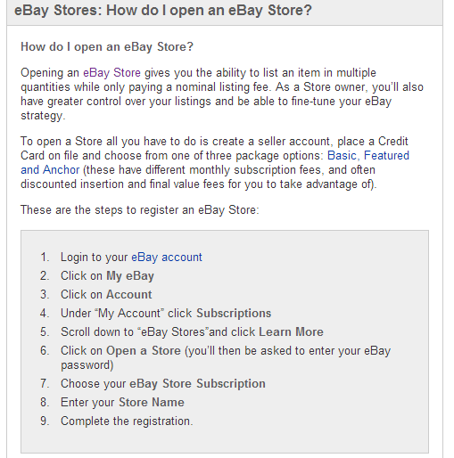

*Above: How to open a new eBay Store*

# How to place an ad on eBay

There are now a few options to place an ad on eBay.

1. Direct onto their website by selecting “Sell” (instructions below)
2. Via your professional eBay Listing Management company (eg. Auctiva)

In order to make a listing on eBay, you simply go to the menu on the top right hand side of any page on eBay and click on “Sell” and the window below will show up when you choose “Sell an item”.

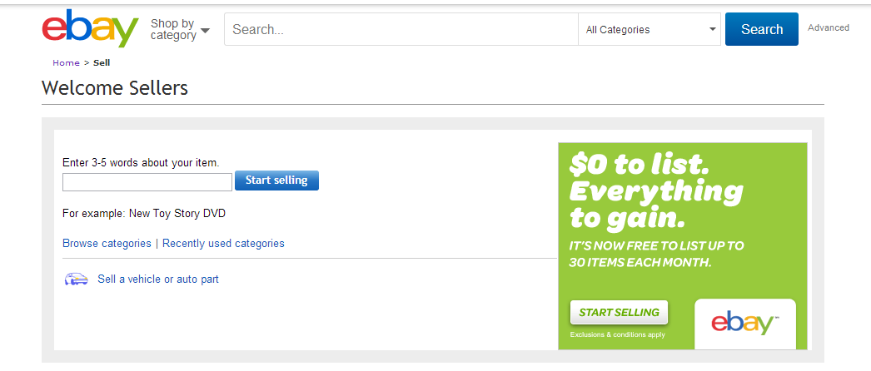

In the above window, simply type the basic word that describes what you are going to sell on eBay (eg. eBook) and it will then respond with “Books on Disc”. Simply select this category by clicking on the box next to “Books on Disc” and then select “Continue”.

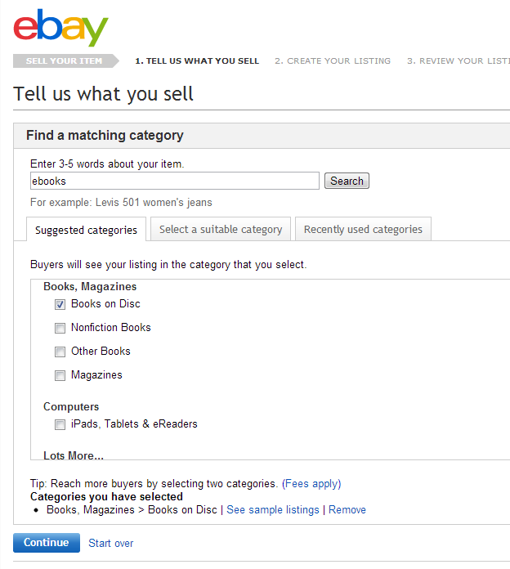

Don’t forget you can list your item on more than one category, but you will have to pay for extra categories. If you have an audio book then it would be worthwhile considering advertising that book on “Books on Disk” and “Audio Books”.

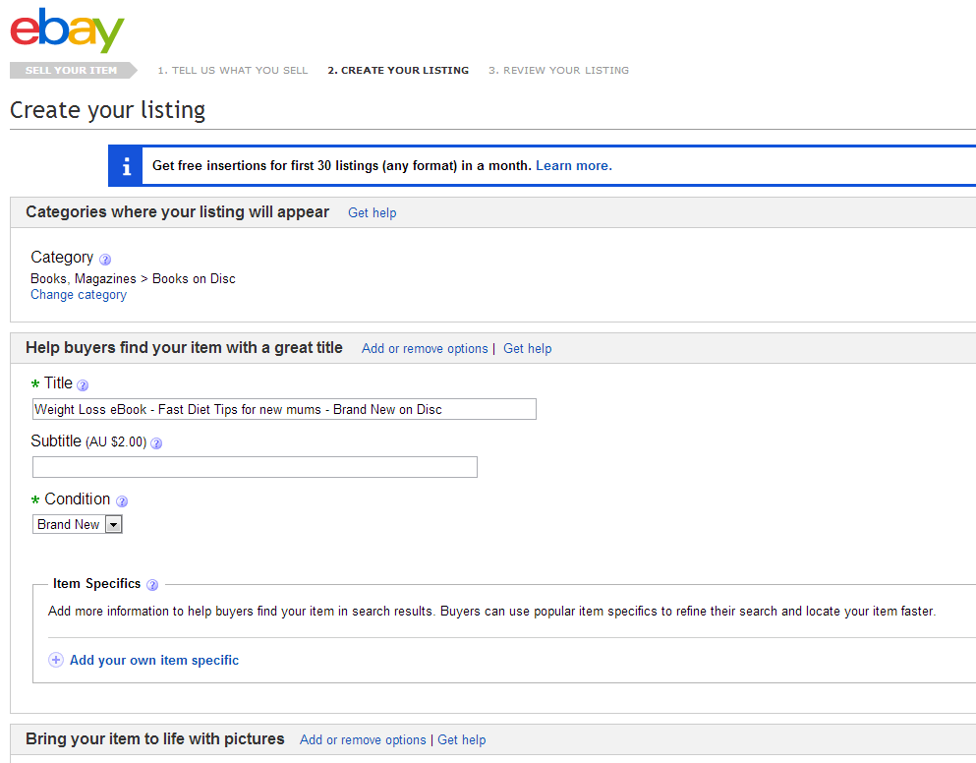

Now your listing page will open up, ready for you to fill in.

Keep your title clear, and full of potential “keyword search words” like new, eBook, Disc, etc. Use as many words as possible, even slang words if it’s relevant to your keyword search (eg. Weight Loss, Diet, Low-Fat, Healthy living etc).

Subtitles will not be worth the $2.00 extra charge, so leave that blank.

Select the condition of your item (which should be Brand New), then you need to make sure your “pictures” of your item makes it relevant to the item, and topic, and looks professional.

The best size for your images are not too important as eBay will resize and compress your images to fit the ad. However, the ideal formatting recommended by eBay for your images is:

* 1600 pixels on the longest side for the best result. The minimum your photos can be without losing quality is 500 pixels on the longest side.
* You can upload pictures in the following file formats (listed in order of what will give you the best results):
  + JPEG (.jpg file extension)
  + PNG (.png file extension)
  + TIFF (.tif file extension)
  + BMP (.bmp file extension)

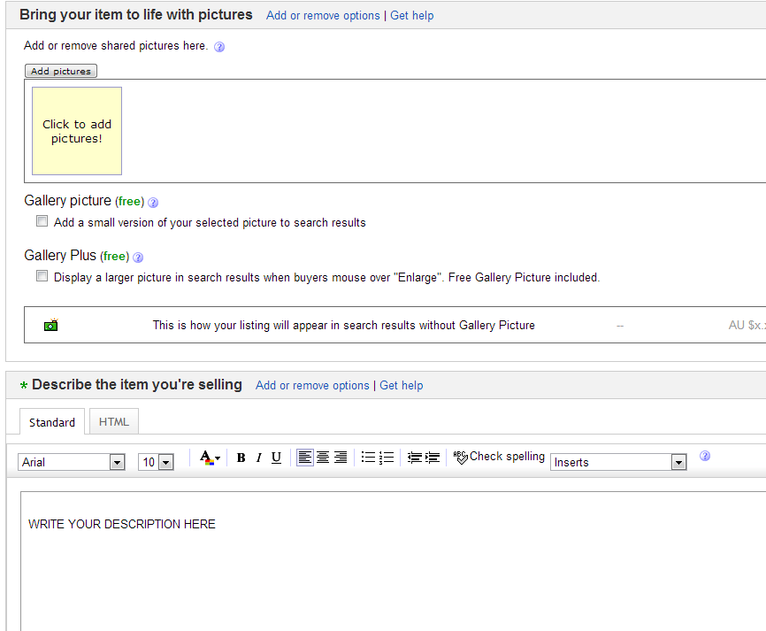

*Above: eBay’s Ad Listing Page Template*

Once you are ready, you should upload your photos – up to 12 pictures are for free.

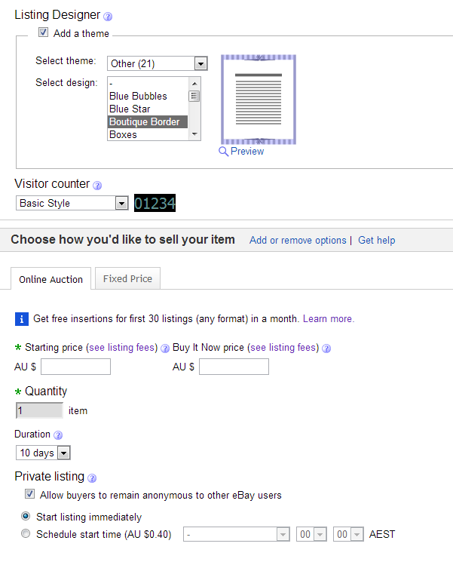

After completing the above choices, simply finish adding your business information like location, postage options and returns information.

On the second page of the listing template you will be required you have entered all the correct information. If you are happy with your listing you can list it immediately.

## Best times to list eBay items for sale

Because your eBay listings are exactly for 3 days or 7 days, whichever you select, the auction (or listing) will end on the same time you list it, unless you “schedule” it for another time (an option that is “Free” for casual eBay sellers after 1 May 2013).

It is always best to have your auction (or listing) end at a popular time with shoppers. Many shoppers will simply search “ending soonest” in order to refine their search based on the theory that the items that are just about to end will give them a very quick result of a cheap purchase.

Most eBay customers shop between 7 and 10pm all nights, and the most popular days are Saturday and Sunday. Monday and Thursday evenings also fair very well. Obviously you can try different times and see which ones sell better for you, but if you are an international seller it may be worth selling everywhere to capture buyers around the world until you know which days are best.

## How long should you list your products for sale

One day listings are only worthwhile for very popular items that people are searching and bidding on all the time (like an iPad) or as a special event (like tickets).

3, 5, 7, 10 days are not very common with eBook resellers on eBay. They all appear to take advantage of the longest listing possible for eBay stores, which is “30 days” or “Goods Till Cancelled”. If you select “Goods Till Cancelled” you still pay every 30 days for a new listing.

## How should you sell your eBooks for on eBay

Prices do vary with resellers, sometimes they list the product as “no postage” and other times the postage is high, and the list price is low, this is probably to avoid higher fees if it sells too. The norm for selling eBooks on eBay appears to be from $2.95 to $9.95 plus postage. The most common price point on eBay for eBooks is $5.95 including postage.

## How much does “print on demand” companies charge

There are a few companies that “print CD’s and DVD’s on demand”. Here are a couple of suggestions you can consider today:

**Trepstar**

They charge $3.96 per unit packaged and posted to anywhere in the US, however, overseas charges are a few dollars higher.

**Kunaki**

Kunaki are another well known “print on demand” company, and charge approximately $5.30 to send their discs anywhere in the world.

## Your eBay Digital Product Ad disclaimers

You need to be clear that your books are on CD’s and not physical hardback books. You’d be surprised how many miss that very clear disclaimer you intend to write on the bottom the salespage. Then they receive their CD in the mail and the first thing they will do is demand a refund, and perhaps even give negative feedback.

In summary, you should try to achieve a good explanation of the following matters on your sales page (and on your eBay custom store pages, if you have a store) wherever possible:

* A good explanation of the digital product (features & benefits)
* A good explanation of what they will actually receive in the mail (CD, electronic book, not physical hardcopy)
* Your terms of payment
* The formats your digital products will be provided in
* Your returns and refund policy
* A disclaimer that any virus obtained from your CD is not something you can insure and they buy at their own risk

You should also write to them after they received their delivery checking they are happy with everything, this minimises complaints down the track.

## Negative Feedback

Negative feedback needs to be avoided if possible because it can affect your status as “Power Seller” and sellers with a good feedback history rank better in eBay “recommended” search engine results.

If you do receive negative feedback, don’t assume it is your competitors. It most like is a genuine customer who feels so disappointed (in their opinion anyway…) that you let them down in some way. If you make the effort to contact them, and offer support for their bad experience you would be surprised how many people will go and remove the negative feedback. Some buyers simply don’t understand the devastating effect negative feedback can have on your eBay selling ratings, and once you show yourself to be genuine and honest, I have always found them to then cancel the negative feedback.

I have received negative feedback for the silliest things sometimes, things that I would never leave negative feedback for myself, but for some reason people use the feedback system to convey their tiniest grievances. So work with them to fix their problem if you can.

# Sales Funnels for eBay sales

Although it is tempting to sell your precious books on eBay for $19.95, they probably won’t sell at that price, unless you are a well known identity that can promote to the masses to come any buy their books online!

Sales Funnels can change all that for you. If you are able to be an affiliate for a more pricey product from your blog or website, simply have cheap CD books on eBay referring to your more expensive perhaps even with a special offer to opt-into your email sign up box, because once you have their email address you can email to them again. This can be for future offers.

The sales funnel would place eBooks sold on eBay right at the wide end of the funnel because it is so cheap to buy, but it can easily escalate that customer into a client when they buy another digital product from you, direct from your website or blog.

# Conclusion

If you have any intention of selling on eBay, get some MRR product, which is pretty cheap to buy now, mock up a few of your own eCovers to keep your products looking different from the regular ones, and see if there is enough sales to justify your new eBay venture.